|  |  |  |
| --- | --- | --- |
| **APPENDIX 2**  **MELVILLE SENIOR HIGH SCHOOL**  **PROCEDURAL FAIRNESS & DELCARATION OF AUTHENTICITY FORM** | |  |
| **STUDENT NAME** | Click or tap here to enter text. | |
| **COURSE/SUBJECT** | Click or tap here to enter text. | |
| **ASSESSMENT TASK** | Click or tap here to enter text. | |
| As a student of Melville Senior High School participating in an out of class/school assessment I declare that:   * All of the work completed in this submission is my own * None of the work performed or submitted was worked upon directly by a teacher or any other person or company except those acknowledged, if appropriate, in the references and acknowledgment section of this assessment * None of the work for this submission was submitted for any other external assessment in any other course * If this is a submission for a timed assessment, that the assessment was completed within the set time period and additional time was not used to complete the assessment unless permitted under Special Educational Arrangements approved by MSHS and SCSA * If this a submission for a timed assessment, that the assessment is completed without any assistance as it would be in a classroom environment and no external support is used unless stipulated in the assessment (ie mobile phone use or text book) * That an onsite assessment may be used to validate the out of class/school assessment(s) and that marks/grades allocated for the out of class assessment are adjusted based on the validation and teacher judgement * That a student may be asked to sit another assessment should it be determined that the assessment submitted cannot be validated * That the appropriate Assessment Policy for the student will be applied should it be determined that the student has cheated or engaged in collusion or plagiarism | | |
| Student Signature: Click or tap here to enter text. | | |
| Date: Click or tap here to enter text. | | |
| Witness (parent/guardian ) Click or tap here to enter text.  Name (typed or written): Click or tap here to enter text.  Signature: Click or tap here to enter text. | | |
| Date: Click or tap here to enter text. | | |

|  |
| --- |
| **Year 11 Specialist Mathematics**  Semester 1, April 2020  **Test 2: Basic Vectors & Circle Theorems**  **Calculator Assumed Weighting: 6%**  **[Australian Curriculum Reference Numbers: 1.2.1 - 1.2.9, 1.2.12, 1.2.14, 1.3.6 – 1.3.15]** |

**Total Time: 50min Total Marks = $\frac{}{54}$**

**Student Name: SOLUTIONS**

**Teacher: ___________________________________**

**INSTRUCTIONS TO STUDENTS:**

* You **are allowed** a CAS calculator
* You **are allowed** 1 A4 page (1 side only) of notes
* A formula booklet will also be provided

You are required to attempt ALL questions.

Write answers in the spaces provided beneath each question.

Marks are shown with the questions.

**Show all working** clearly, in sufficient detail to allow your answers to be checked readily and for marks to be answered for reasoning. Incorrect answers given without supporting reasoning cannot be allocated any marks. For any question or part question worth more than two marks, valid working or justification is required to receive full marks.

1. Given $a=\left(4, 35°\right), b=\left({-3 \atop -6}\right) and c=6i-j$, determine:
2. $2a-b$, in component form.

|  |
| --- |
| $$=9.55i + 10.59j$$ |
|  |
|  |
|  |

1. $4(c-a)$, in polar form, with a positive angle.

|  |
| --- |
| $$=(17.1, 309.58°)$$ |
|  |
|  |
|  |

1. Vector $d$ that has a magnitude of 10 and is in the same direction of $a+b+c$, in terms of $i and j.$

|  |
| --- |
| $$a+b+c=(6.28,-4.71)$$ |
| $$∴unit vector in direction ofa+b+c is (0.8,-0.6)$$ |
| $$∴d= 10 \left(0.8,-0.6\right)=8i-6j$$ |
|  |
|  |
|  |
|  |
|  |
|  |
|  |
|  |

**[1, 2, 3 = 6 Marks]**

1. In a parallelogram $ABCD$, $\vec{AB}=a$ and $\vec{AD}=b$.   
   E is a point on $DC$ such that $CE:ED=3:1$. Express $\vec{EB}$ in terms of $a$ and/or .

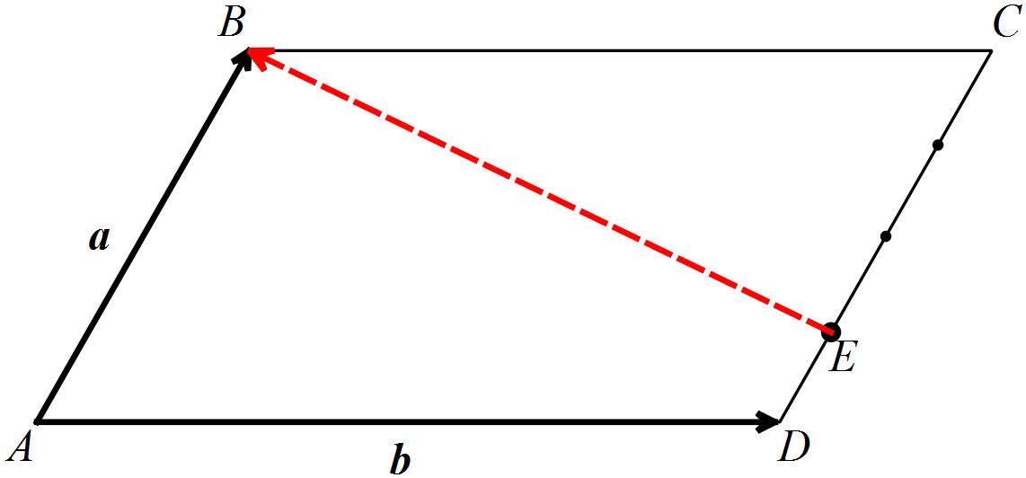





|  |
| --- |
|  |
|  |
|  |
|  |
|  |

[3 Marks]

1. If $a=-4i+6j$ and $b=3i-2j$, show that the vector in the direction of $a$ that has half the magnitude of $b$ is .

|  |
| --- |
|  |
|  |
|  |
|  |
|  |
|  |
|  |

**[4 marks]**

1. 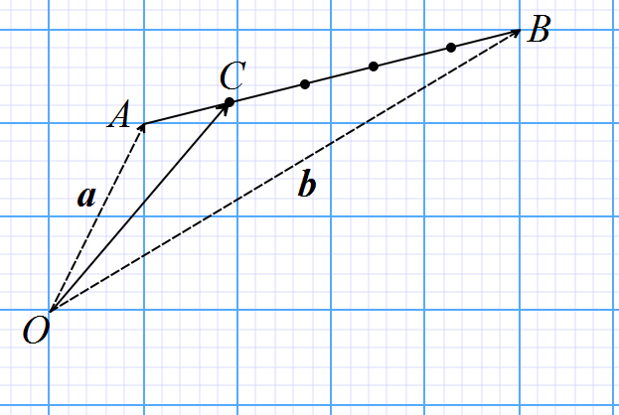Points A and B have position vectors $5i+10j$ and $25i+15j$ respectively. Find the position vector of the point that divides AB internally in the ratio $1:4$.

|  |
| --- |
| $$\vec{OC}=\vec{OA}+\vec{AC}$$ |
| $\vec{OC}=\vec{OA}+\frac{1}{5}\vec{AB}$ |
| $$\vec{OA}=a and \vec{AB}=b-a$$ |
| $$∴ \vec{OC}=a+\frac{1}{5}(b-a)$$ |
| $$∴\vec{OC}=\frac{4}{5}a+\frac{1}{5}b$$ |
|  |
| $$∴\vec{OC}=\frac{4}{5}(5i+10j)+\frac{1}{5}(25i+15j)$$ |
| $$∴\vec{OC}=4i+8j+5i+3j$$ |
| $$∴\vec{OC}=9i+11j$$ |
|  |
|  |

**[5 marks]**

1. If it is known that $a and b$ are not parallel and are also not zero, determine exact values of λ and μ such that: $λa+b-μb=4a+μa-4λb$**.**

|  |
| --- |
| $$λa-4a-μa=-4λb-b+μb$$ |
| $$(λ-4-μ)a=(-4λ-1+μ)b$$ |
| $$λ-4-μ=0 and -4λ-1+μ=0$$ |
| $$λ=-\frac{5}{3}, μ=-\frac{17}{3}$$ |
|  |
|  |
|  |
|  |
|  |

**[5 Marks]**

1. Determine the value of the pronumerals (all external lines are tangents).

|  |  |
| --- | --- |
| $$x=110°$$ | $$a=56°$$ |
| $$y^{2}=2\left(y+4\right) \\ y^{2}-2y-8=0 \\ y=4$$*** No marks if they also give $y=-2$*** | $$y=57°$$ $$z=103°$$ $$x=20°$$ |
| $$y=95°$$ $$x=85°$$ | $$x=71°$$ $$y=62°$$ |

[1,1,1,3,2,2 = 10 marks]

1. ****Prove that $A,B,C and D$ are concyclic, that is lie on the same circle.

|  |
| --- |
| $$∠DAC=63=∠DBC (angle sum of triangle)$$ |
|  |
| $$Angles at the circumference of a circle subtended \\ by the same chord are equal.$$ |
|  |
| $$∴A and B lie on the circumference of a circle and subtend angles from chord CD$$ |
| $$∴A ,B, C and D must lie on the same circle and are concyclic$$ |
|  |

[4 marks]

1. 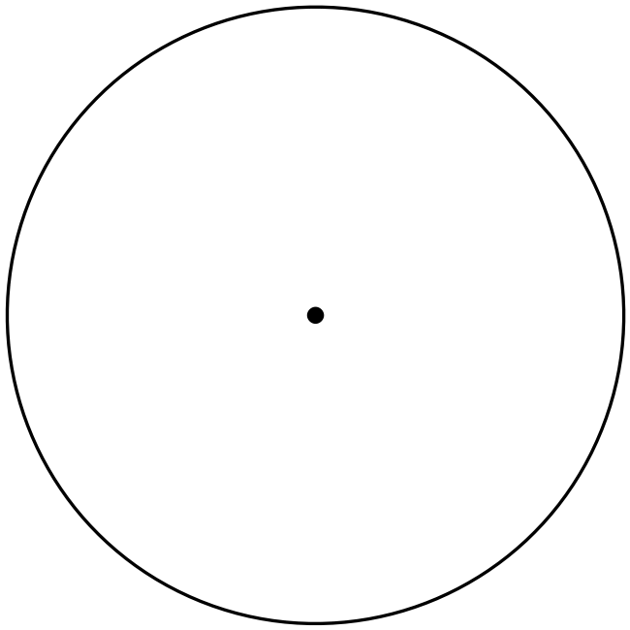Prove the following statement:

|  |
| --- |
|  |
|  |
|  |
| Image result for red tick no background |
|  |
|  |
| Image result for red tick no backgroundImage result for red tick no background  Angle in Semicircle |
| Image result for red tick no backgroundImage result for red tick no background  Angles subtended by same arc equal |
| Image result for red tick no background |
| *** Various answers – mark accordingly *** |

[6 Marks]

1. In the diagram, $A, C, D and E$ lie on the circle with centre $O$. $AB$ is a tangent. Determine the pronumerals, giving reasons for each step of your working.

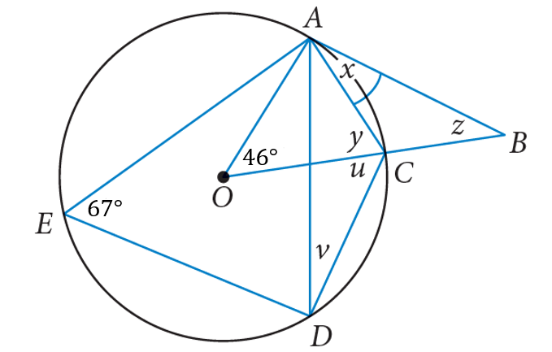

Image result for red tick no backgroundImage result for red tick no background

|  |
| --- |
|  |
|  |
| Image result for red tick no backgroundImage result for red tick no backgroundImage result for red tick no background |
|  |
|  |
|  |
| *** Do not award mark for a value if valid reasoning not shown *** |
| $$***Various solutions-mark accordingly***$$ |

[5 Marks]

1. 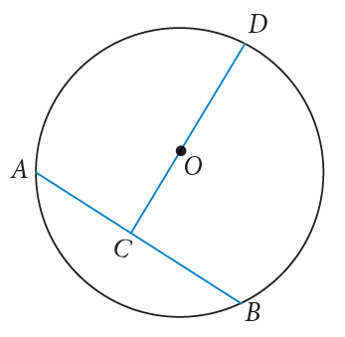A circle with centre O has radius $r$ and chord $AB=x$, with $AC=CB$.   
     
   Show that

|  |
| --- |
|  |
|  |
|  |
| Image result for red tick no background |
|  |
| Image result for red tick no background |
|  |
| Image result for red tick no background |
| Image result for red tick no background |
| Image result for red tick no background |
|  |
| Image result for red tick no background |
|  |
|  |
|  |
|  |
|  |
|  |

[6 Marks]

**\*\*\* End of Test \*\*\***

***Extra space for working out***

|  |
| --- |
|  |
|  |
|  |
|  |
|  |
|  |
|  |
|  |
|  |
|  |
|  |
|  |
|  |
|  |
|  |
|  |
|  |
|  |
|  |
|  |
|  |
|  |
|  |
|  |
|  |